Final Year Design Project (FYDP)
Report Guidelines

This section contains information to format the Final Year Design Project (FYDP) Report in NED University of Engineering and Technology. It is important to thoroughly read this document to properly organize and format your FYDP report. Reports that do not fulfill all of the criteria mentioned in this document will not be approved by the department.

To keep a consistent format of FYDP report among all students, it should be formatted in the following manner.

Final year project report is divided into three sections: Front Section, Main Body, and Back Section.

- Front Section is from the Title page to the Similarity Index Report page.

- Main Body is from the first chapter Introduction till the last chapter Conclusion.

- Back Section includes the content after the Main Body. It includes References, Appendices, Glossary, and Letter of Copyright Permission (if required).

Page Numbering:

The style of page numbering of the Front Section is different from the Main Body and Back Section. Page numbers should be shown on all pages at the bottom-center of pages except on the front title page and blank pages (if any). However, ensure that the title page and blank pages are counted in the page numbering.

Front Section:

- Page numbers in the front section must be labeled in lower case Roman numerals (i, ii, iii)

- Title page should be considered as a page i, however, do NOT show page numbering on the title page. Therefore, page numbering should be shown from the next page (that is page ii).
- The details of pages that should be included in the front section are mentioned later in this document.

Main Body and Back Section:

  - In these two sections, Arabic numerals (that is 1, 2, 3 …) should be used.

  - The first page of the Main Body section will be labeled as page number “1” (that is re- start page numbering from this section).
  - However, the page numbering will remain continuous afterward. That is page numbering should remain continuous from the first page of the main body section until the last page of the back section.

The front matter of the project should be organized in the following order.

Page Headings | Page  Number | Remarks
Title page | - | Compulsory page.  Follow the sample title page given in the project template. This page should include Copyright Notice, with the date  and year the document is submitted. Moreover, signatures of the author(s) and advisor(s) are required on this page.  Avoid using formulae, Greek letters, superscripts, and symbols on the title page because this will make it difficult to search your project online. Replace Greek letters with their names.  This page will be “counted” as page number i, however, the page number should not be visible on the front page.
Author's  declaration | ii | Compulsory page.  Page numbering should be visible on this page and the following pages. This page will be counted as page number ii.
Statement of  Contributions | iii | Compulsory page.  Mention the contributions of each student in the project

report work. Clearly state who contributed to each task and

to which extent. It should be in bullet points. For example:

- Mr. AB and BC have performed modeling, simulation, and finite element analysis of the wind turbine blades.
- Mr. XY and YZ have performed fabrication work.

They visited markets to purchase fiberglass, steel, and other materials for the wind turbine.
- Mr. AB carried out 4 out of 7 experiments while Mr.

YZ carried out the remaining 3 experiments. However, all group members have jointly planned the experiments and interpreted the results.
- All authors contributed equally to write the final year project report.
Executive  Summary | iv | Compulsory page.  The summary should be less than 350 words.
Acknowledgements | v | Compulsory page.
Dedication | vi | Optional page.
Table of contents | vii | Compulsory page.
List of figures | viii | Skip this page if the document does not have any figures.  Figures should be properly numbered according to their chapter numbers. They should follow the usual guidance on margins. The caption of figures should be on the same page as the figure and should be located at the bottom of the figures.  Figures must be properly referenced in the text (do not write the “above/below figure” instead write the figure number). Figures must be embedded after and close to where they have cited for the first time.

Most of the figures must be from the original work of the

students. Extensive use of figures from other sources is not allowed.
List of tables | ix | Skip this page if the document does not have any table.  Tables should be properly numbered according to their chapter numbers. They should follow the usual guidance on margins. The caption of tables should be on the same page as the table and should be located at the top of the tables.  Tables must be properly referenced in the text (do not write the above/below table instead write the table number). Figures must be embedded after and close to where they have cited for the first time.
List of abbreviations | xi | Skip this page if you have not used abbreviations in your report.
List of symbols | xii | Skip this page if you have not used symbols.  If you have used symbols in your report, then the description of those symbols should be given on this page. A two-column format can be used as given in the template. Moreover, you can also arrange and categorize symbols into sub-headings for ease of reading.
Graphic or quote | xiii | Skip this page if you do not wish to include a graphic or  quote.  However, you can include a graphic or a relevant quote on this page.
United Nations | xiv | Compulsory page.
Sustainable
Development |  | Mark the appropriate SDGs related to the project on this
Goals (SDGs) |  | page. Remember that this page should be the last page of the
 |  | front matter before the main body of the project.
Similarity Index | xv | Plagiarism test must be conducted on the project report by

Report |  | the project advisor using Turnitin Software, or any other  software approved by the university. Students will be required to bring the similarity in acceptable range as prescribed below:  - Overall acceptable range of similarity index either from student’s own previous work or the work of some other person(s) is less than 20%.  - Maximum acceptable range of similarity index from an individual link is 5%.  - While conducting a similarity test, the following settings should be followed:  - Exclude bibliographic material = Yes  - Exclude small matches = Yes  - Exclude matches by Word count = 5 words  - All other settings left at default  Project Advisor is required to sign the Similarity Index Report provided in the FYDP template file if the similarity is found as per rules defined above.  Moreover, include the first and last page of the plagiarism report generated by Turnitin here. A sample of the plagiarism test report is provided with the FYDP template package.

The back matter of the project should be organized in the following order.

Page Headings | Remarks
Letter of  copyright permission | Optional.  If your project includes any substantial work from other authors, you may be required to take written permission from the authors and attach letter(s)

of copyright permission with the project report.

A sample letter of copyright permission is provided. You may use this sample by replacing all text written inside square brackets with your own information.
References (or  Bibliography) | Compulsory page.  All references should be included together at the end of the document. The reference not cited in the report should not be included in the reference list.  For referencing any article and/or book APA (American Psychological Association) referencing style must be used. Following are the examples of APA reference style to be used in the report.  Journal Article Reference  Akhtar, M., Qamar, S. Z., Mehdi, S. M., & Hussain, A. (2019). Diffusion- based swelling in elastomers under low-and high-salinity brine. Journal of Elastomers & Plastics, 51(1), 75-84.  Book Reference  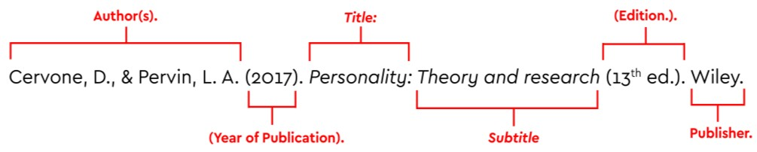  Beer, F. P., Johnston, E. R., DeWolf, J. T., & Mazurek, D. F. (2017). Statics and mechanics of materials. New York: McGraw-Hill Education.

Arrange references in alphabetical order of the surnames of the first

authors in the list of references. Moreover, if two references have the same first author, then arrange the references by the surname of the first author and then by the surname of the second author. Also note that for in-text citation APA uses the author's surname and the year of publication enclosed in brackets, for example (Shepherd, 1956).

Referencing can be done either by using third-party software (Endnote) or by using built-in referencing tool in MS Word. It is highly recommended that a central repository of references is stored in a third-party platform which can be imported into any document. Mendeley is one such free online platform that is used to manage references. It has MS Word extension and browser add-on for seamless referencing. More details on Mendeley are available at: https://www.mendeley.com/guides/mendeley- reference-manager.
Appendices | Skip this page if the document does not have appendices.
Glossary | Skip this page if the document does not have a glossary.
Index | Skip this page if the document does not have an index.  However, if you have used any jargons or words not from your stream of specialization, or newly added words in the literature, take this opportunity to let your readers know what you mean by them. Arrange the words in alphabetical order.

Paper Size:

    - A4 size paper should be used to print the document.

Margins:

    - Margins should be 1.5 inches on the binding edge. That is if the document is to be printed double-sided, left-side margin should be 1.5 inches for odd number pages and right-side margin should be 1.5 inches for even number pages. However, if the document is to be printed single-sided, the left-side should have 1.5 inches margin on all (even and odd) pages.

- All remaining margins should be 1 inch.

- Page numbers, headers, and footers can be within the above-described margins.

However, a minimum gap of ½ inch is still required from the edge of pages.

Binding:

- Outside binding should be navy blue.

Font:

- Use Times New Roman with 12 font size. However, notes and captions should not be smaller than 10 points.
- Maintain consistency in the use of different typefaces for headings, footings, and titles.

Line Spacing:

- The spacing between lines should be 1.5 for the main body. However, headers, footnotes, tables, captions, and indented quotations should be single-spaced.
- Moreover, use single spacing for the front and back sections (nevertheless, 1.5 spacing can be used for appendices).

Title page:

- The format of the title page must be the same as the one given in the project template.

- The name of the degree should not be abbreviated. For example, write Bachelor of Engineering instead of B.E.
- The copyright notice © must be present on the title page with the project submission year.

Author's declaration:

This page should include the following statement:

“We declare that we are the sole author(s) of this project report. It is the actual copy of the project report that was accepted by our supervisor(s) including any necessary revisions. We

also grant NED University of Engineering and Technology permission to reproduce and distribute electronic or paper copies of this project report.”

Equations:

Use MathType in MS Word to type equations. Equations should also be numbered according to their chapter numbers. All equations should be indented form the left margin and equations numbers be aligned to the right-side margin on the same line and enclosed the equation numbers in small brackets. For instance, if equations are present in chapter three, then equation numbers will be like (3.1), (3.2), (3.3), etc. Do not use solid or dotted lines between equations and their equation numbers.

If you like to cite an equation in the middle of a sentence, then write “Eq.” when referring to a single equation (or “Eqs.” when referring to several equations) before the equation number. However, if the equation is to be cited at the beginning of a sentence, then write “Equation” (or “Equations” when referring to several equations) before the equation number.

For example, “The formula of the laminar flow is given in Eq. (3.1). This formula is valid for specific range of Reynolds number. Equation (3.2) gives the formula of turbulent flow. Moreover, formulas of heat transfer rate for turbulent flow are given in Eqs. (3.3) and (3.4)”

𝑹�= 𝝆𝑽𝑫
𝝁

(3.6)

Other Considerations:

- Every chapter or section should be beginning from a new page.

- The first chapter of the FYDP report should be “Introduction” and the last chapter should be “Conclusions”. All chapters are the part of Main Body section of the report.
- American or British spelling and grammar can be used in the project; however, the author(s) should remain stick to one style throughout the document to maintain consistency.
- Words should not be divided from one page to the next page.

- Do not end a paragraph such that an isolated last line of the paragraph appears on the top of a page.
- Make sure that the document does not have an isolated heading at the bottom of the page that is not followed by its text on the same page.

- If a graph, figure, table, chart, etc. is required to be printed in landscape form, then they should be oriented facing away from the binding edge of the paper.
- If a graph, figure, table, chart, etc. cannot be reduced to the standard Letter size page, an oversized sheet may be used; but it should be folded to end within the text area of the page.
- All graphs, figures, tables, charts, etc. should follow the margin limit as described above.
- Use italics style for words other than English except proper nouns.

- Any reference system can be selected but it should remain consistent throughout the document.
- References must appear in ascending order where they have first cited.

- Do not forget to write “THIS PAGE IS INTENTIONALLY LEFT BLANK” at the center of the blank pages, if any.
- If you have used copyrighted material beyond a reasonable limit (e.g., the use is affecting the market value of the copyrighted material, you have substantially used the copyrighted material, and/or you have used it for commercial purpose instead of nonprofit educational purpose), a letter of permission should be submitted for the copyrighted material. The permission should be obtained from the owner of the work.
- Use the standard template as given in the project template package.

Guidelines to use the template of final year project report (MS Word file):

- Write your project details by replacing all text enclosed in square brackets in the project template file.
- Delete any text in the template that is written for your guidance.

Heading Styles in FYDP template:

FYDP template has 6 types of heading styles. Use Heading 1 style for chapters, Heading 2 style for sections, and Heading 3 style for sub-sections.

Headings 1 style is aligned to the center of the page while all other heading styles are aligned to left margins. You have the freedom to change the alignments of headings, font themes, and font sizes of these heading styles. You can do this by going to the Home tab,

where you will find the Style section. In this section, right-click on the heading style that you want to change. Then, click on the Modify button and make your desired modifications.

Numbering of Headings in FYDP template:

The numbering of headings in this template has been done according to the legal numbering format. You can choose a different numbering style. You may also skip numbering after the 3rd heading level.

Table of Content:

To update table of content, right click on the table, then click on “Update Field”. Do not manually add/delete contents in the table of content.

List of Figures and Tables:

To update the list of figures or list of tables, right click on the list, then click on “Update Field”. Do not manually add/delete text in these lists.

FINAL YEAR
PROJECT REPORT TEMPLATE

UNDERGRADUATE FINAL YEAR PROJECT REPORT

Department of ______________________ NED University of Engineering and Technology

[Title of the Project]

Group Number:
Batch: 20__ – 20

Group Member Names:

[Name of Student] [Seat Number]

[Name of Student] [Seat Number]

[Name of Student] [Seat Number]

[Name of Student] [Seat Number]

Approved by

……………………………………………………………………………………………...

[Name of Project Advisor] [Designation of Advisor]
Project Advisor

© NED University of Engineering & Technology. All Rights Reserved – [Month Year]

Author’s Declaration

We declare that we are the sole authors of this project. It is the actual copy of the project that was accepted by our advisor(s) including any necessary revisions. We also grant NED University of Engineering and Technology permission to reproduce and distribute electronic or paper copies of this project.

Signature and Date

.................................

.

[Name of Student] [Seat Number]
Signature and Date

.................................

.

[Name of Student] [Seat Number]
Signature and Date

.................................

.

[Name of Student] [Seat Number]
Signature and Date

.................................

.

[Name of Student] [Seat Number]

[Email address] [Email address] [Email address] [Email address]

Statement of Contributions

[Mention here the contributions of each student in the project report work.]

Executive Summary

Write the summary of report here. Limit the summary to 350 words and use single- spacing between lines. It should include the following details:

  - Problem statement

  - Background information

  - Methodology used to solve the problem

  - Major findings

  - Conclusions

It should give a clear idea to the reader about what is included in the report without providing excessive details. Do not include citations, figures or cross references to tables and figures in the summary.

Acknowledgments

[Write the acknowledgments here. Use single-spacing between lines. You can acknowledge any faculty member, any national or international organization, or sponsor for helping you out in completion of this project. They may have provided you valuable resources in the form of data, personal experience, disciplinary expertise, instruments, or technical support. Ideally it should be one or two short paragraphs.]

Dedication [Optional]

[Write dedication here. You may want to dedicate this work to immediate family members or members of a board or society that works for your cause. Ideally, it should be only one or two lines in length. However, if you do not wish to include a dedication, delete this page. After deleting this page and updating the table of contents, this page will automatically disappear from the table of content. In case, you have decided to delete this page, the table of contents should begin from page v.]

Table of Contents
Author’s Declaration ii
Statement of Contributions iii
Executive Summary iv
Acknowledgments v
Dedication [Optional] vi
Table of Contents vii
List of Figures viii
List of Tables ix
List of Abbreviations x
List of Symbols xi
United Nations Sustainable Development Goals xii
Similarity Index Report xiii
Chapter 1 Introduction 1
  - Background Information 1
  - Significance and Motivation 1
  - Aims and Objectives 1
  - Methodology 1
  - Report Outline 2
Chapter 2 Literature Review 3
  - Introduction 3
  - [Title of the Section] 3
  - [Title of the Section] 4
  - More Sections 4
  - Summary 4
Chapter 3 [Name of the Chapter] 5
3.1 Introduction 5
Chapter 4 [Name of the Chapter] 6
4.1 Introduction 6
Chapter 5 Conclusions 7
  - Summary 7
  - Recommendations for Future Work 7
Appendix A [Title of Appendix] 8
References 9
Glossary [Optional] 10

List of Figures
Figure 1: Trend of Monthly Average High and Low Temperatures in Karachi (Shepherd, 1956) 4

List of Tables
Table 1: Residual Stresses for a Plate 4

List of Abbreviations

FPC Flat Plate Collector

TSS Tubular Solar Still

EPBP Economic Payback Period

List of Symbols

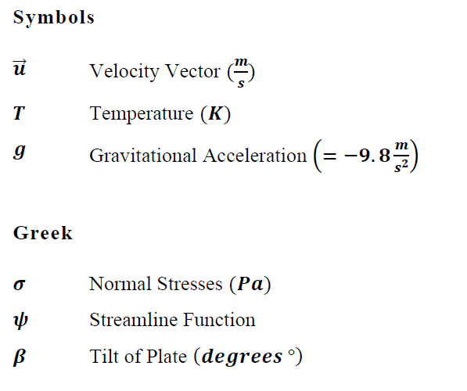

United Nations Sustainable Development Goals

The Sustainable Development Goals (SDGs) are the blueprint to achieve a better and more sustainable future for all. They address the global challenges we face, including poverty, inequality, climate change, environmental degradation, peace and justice. There is a total of 17 SDGs as mentioned below. Check the appropriate SDGs related to the project.

- No Poverty

- Zero Hunger

- Good Health and Well being

- Quality Education

- Gender Equality

- Clean Water and Sanitation

- Affordable and Clean Energy

- Decent Work and Economic Growth

- Industry, Innovation and Infrastructure

- Reduced Inequalities

- Sustainable Cities and Communities

- Responsible Consumption and Production

- Climate Action

- Life Below Water

- Life on Land

- Peace and Justice and Strong Institutions

- Partnerships to Achieve the Goals

Similarity Index Report

Following students have compiled the final year report on the topic given below for partial fulfillment of the requirement for Bachelor’s degree in _____________________.

Project Title

S. No. Student Name |  |  | Seat Number | Signature
1.

2.

3.

4.

This is to certify that Plagiarism test was conducted on complete report, and overall similarity index was found to be less than 20%, with maximum 5% from single source, as required.

Signature and Date

..................................
[Name of Advisor] [Plagiarism Test must be conducted on the project report by the project advisor using
Turnitin Software, or any other software approved by the university. Project Advisor is required to sign the Plagiarism Certificate if the similarity is found as per rules defined in the guidelines. Plagiarism report must be included (only the first and last page) generated by Turnitin. A sample of the plagiarism test report is provided with the FYDP template package.]
xiii

[Attach here the first and last page of the plagiarism report generated by Turnitin.]

Chapter 1 Introduction

Background Information

A project report usually contains five or six chapters. Chapters should be divided into sections that should be numbered according to their chapter numbers. For instance, the numbering of sections of chapter one should be 1.1, 1.2, 1.3, etc.

The first chapter should be “Introduction” and it should provide the background information related to the project. The first section of the Introduction chapter should be titled “Background Information”. While the other sections should be “Significance and Motivation”, “Aims and Objectives”, “Methodology” and “Report Outline/Scope” of the Project. It should inform the readers what you did in the project, why you did it, and how you achieved it. This chapter provides a broad overview on what is discussed in the report.

Significance and Motivation

The second section of the chapter one should be “Significance and Motivation”. It should include the importance of the project and its benefits.

Subsections should have numbering in accordance with its chapter and section number. For example, the numbering of subsections in section two of chapter one should be like 1.2.1, 1.2.2, 1.2.3, etc. It is not recommended to have only a single subsection in a section.

Aims and Objectives

The third section of the chapter one should be “Aims and Objectives”.

Methodology

The fourth section of the chapter one should be “Methodology”. It should include the details of the methodology that you have used to solve the problem.

Report Outline

The fifth section of the chapter one should be “Report Outline”. It should include the scope of the project and explain the general outline of the report by highlighting the content that is covered in different chapters and sections.

Kindly include more sections in the Introduction chapter if you prefer.

Chapter 2 Literature Review

Introduction

Except for the Introduction chapter (first chapter) and the Conclusion chapter (last chapter), all other chapters should have first section titled “Introduction” and last section titled “Summary/Conclusions”. In Introduction sections, discuss the content of chapters such that the readers will have an idea about what is discussed in the chapters. This allows the readers to know in advance if the chapter is relevant to their interests. On the other hand, the Summary sections discuss what has been achieved in the chapters. Write the Summary sections by keeping in mind that many readers do not have time to read the complete chapters; therefore, they only read Summary sections to get an overview. Consequently, include the most important achievements and aspects in these sections and use past tense to write Summary sections.

The goal of this chapter is you discuss how your work is different from the work already done in the field. You should present a critical review on the past work on your topic. This chapter will in return help students to gather updated knowledge on the project and this will enable them to understand the limitations of previous work done on your topic.

[Title of the Section]

A sample graph is shown in the Figure 1. Always use the “Insert Caption” option to insert the figure label and numbering automatically. This will also automatically update them in the List of Figures. Captions of figures should be given on the bottom of the figures. To refer to a figure in the text go to References in the Ribbon, then click on Cross-reference, then select Figure in Reference type, then select Only label and number in Insert reference to.

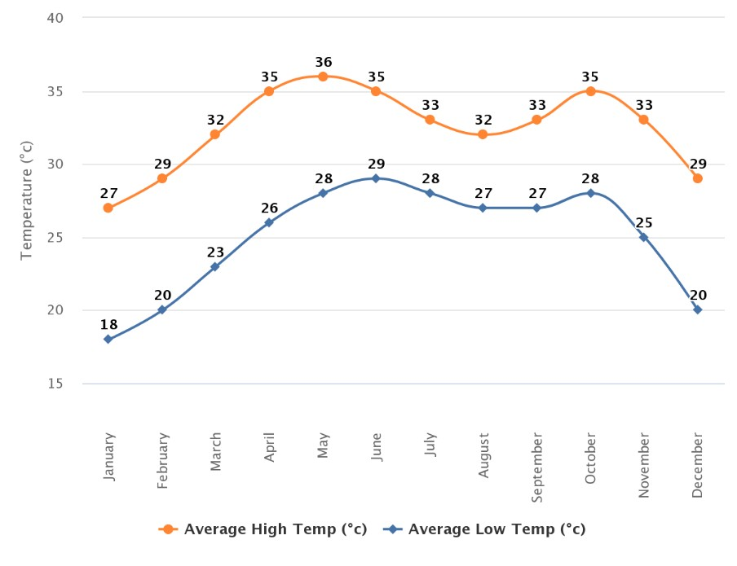

Figure 1: Trend of Monthly Average High and Low Temperatures in Karachi (Shepherd, 1956)

[Title of the Section]

A sample table is shown in the Table 1. Always use the “Insert Caption” option to insert the figure label and numbering automatically. This will also automatically update them in the List of Figures. Captions of tables should be given on the top of the tables. To refer to a table in the text go to References in the Ribbon, then click on Cross-reference, then select Table in Reference type, then select Only label and number in Insert reference to.

Table 1: Residual Stresses for a Plate

Orientation | 𝝈�(𝑴𝑷𝒂) | 𝝈�(𝑴𝑷𝒂) | 𝝉��(𝑴𝑷𝒂) | 𝝉��(𝑴𝑷𝒂) | 𝝉��(𝑴𝑷𝒂)
0° | -0.282 | -0.143 | 0 | 0 | 0
90° | 0.282 | 0.143 | 0 | 0 | 0

More Sections

Include sections as appropriate to your literature review.

Summary

Last section of each chapter should be Summary or Conclusion.

Chapter 3 [Name of the Chapter]

3.1 Introduction

Include more chapters as appropriate to your project. All chapters should start from a new page. The middle chapters should discuss your work on the project. Some famous headings for these chapters are Design and Calculations, Modeling and Simulations, Fabrication Work, Data Acquisition and Analysis, Comparison of Methods, Results, Discussion/Interpretation of Results, etc.

Chapter 4 [Name of the Chapter]

4.1 Introduction

More chapters.

Chapter 5 Conclusions

Summary

The last chapter should be “Conclusions”. It is ideally the fourth or fifth section of the report. This chapter should include the aims and objectives of the project. It should also summarize the important points in the previous chapters, and the findings and achievements of your project. If possible, write some recommended future work on the project based in your conclusions. Therefore, the last section of this chapter should ideally be “Recommendations”. For example, you may provide recommendations by discussing constraints of your project and ideas to eliminate them. You may also highlight other possible investigations to improve the efficiency of your project. Use present perfect tense to write the conclusions. The recommended two sections for the Conclusions chapter are “Summary” and “Recommendations for Future Work”.
Do not use cross referencing, external references, or footnotes in the Conclusions chapter. Make it a stand-alone chapter.

Recommendations for Future Work

Write details here.

Appendix A [Title of Appendix]

Include appendices, if applicable. Appendices should include the information that is not the primary part of the main body of the project report. This means that if this information is removed from the main body, it would not negatively affect the flow of ideas in the main body of the report. For example, it may include long computer programming codes while keeping a flow chart of the code in the main body of the report. It may also include lengthy numerical data while keeping their graphs in the main body of the report.

If the project report has only one appendix, then the label of this chapter should be “Appendix” (not “Appendix A”). To cite an appendix in the text, write full title of the appendix that is “Appendix A”, “Appendix B”, etc. Each appendix should start from a new page and should also include a short description of what is included in that appendix.

References

Shepherd, D. G. (1956). Performance of one-row tube coils with thin-plate fins, low velocity forced convection. Heating, Piping Air Cond, 28, 137-144.

Glossary [Optional]

Term | Definition | [Page at which it  first appeared]
Azimuth angle between North, measured clockwise around the Pg. 1

observer's horizon and sun

Zenith an imaginary point directly above the observer/system, complement of altitude angle

Pg. 5

PLAGIARISM
TEST

REPORT SAMPLE

Paper

ORIGINALITY REPORT

SIMILARITY INDEX INTERNET SOURCES PUBLICATIONS

PRIMARY SOURCES

www.engJ.org
Internet Source

www.tandfonline.com
•
Internet Source

www.oak.go.kr
•
Internet Source
%

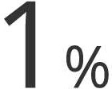STUDENT PAPERS

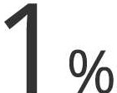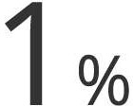Habib Daoud Zughbi, Shaikh Abdur Razzak. "Simulation of Flow and Chemical Reactions in
1%
•
&
a Claus Sulfur Converter", Industrial
Engineering Chemistry Research, 2005
Publication
II <1%

www.meca.unicaen.fr
Internet Source

J. Benajes, R. Novella, J.M. Pastor, A. Hernandez-Lopez, T. Duverger. "A computational analysis of the impact of bore- to-stroke ratio on emissions and efficiency of a HSDI engine", Applied Energy, 2017
• <1%
Publication

• digital.library.adelaide.edu.au

Air or in Diesel Emulsion on the Performance and Emissions of a HDDI Diesel Engine", journal of Energy Engineering, 2020
Publication

N. Saravanan. "Hydrogen-diesel dual fuel 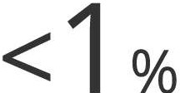 combustion in a direct injection diesel
II
engine", International journal of Renewable Energy Technology, 2011
Publication

Exclude quotes On

Exclude bibliography On
Exclude matches < 5 words

